**Create Eureka Discovery Server and register microservices**

**Step-1:Create and Launch Eureka Discovery Server**

* Using https://start.spring.io created a project with following configuration:
* Group: com.cognizant
* Artifact: eureka-discovery-server
* Module: Spring Cloud Discovery > Eureka Server
* Included **@EnableEurekaServer** in class EurekaDiscoveryServerApplication

**EurekaDiscoveryServerApplication.java**

**package** com.cognizant.eureka_discovery_server;

**import** org.springframework.boot.SpringApplication;

**import** org.springframework.boot.autoconfigure.SpringBootApplication;

**import** org.springframework.cloud.netflix.eureka.server.EnableEurekaServer;

@SpringBootApplication

@EnableEurekaServer

**public** **class** EurekaDiscoveryServerApplication {

**public** **static** **void** main(String[] args) {

SpringApplication.*run*(EurekaDiscoveryServerApplication.**class**, args);

}

}

* Changed the configurations in application.properties:

**application.properties**

spring.application.name=eureka-discovery-server

server.port=8761

eureka.client.register-with-eureka=false

eureka.client.fetch-registry=false

logging.level.com.netflix.eureka=OFF

logging.level.com.netflix.discovery=OFF

**OUTPUT:**

**http://locahost:8761**

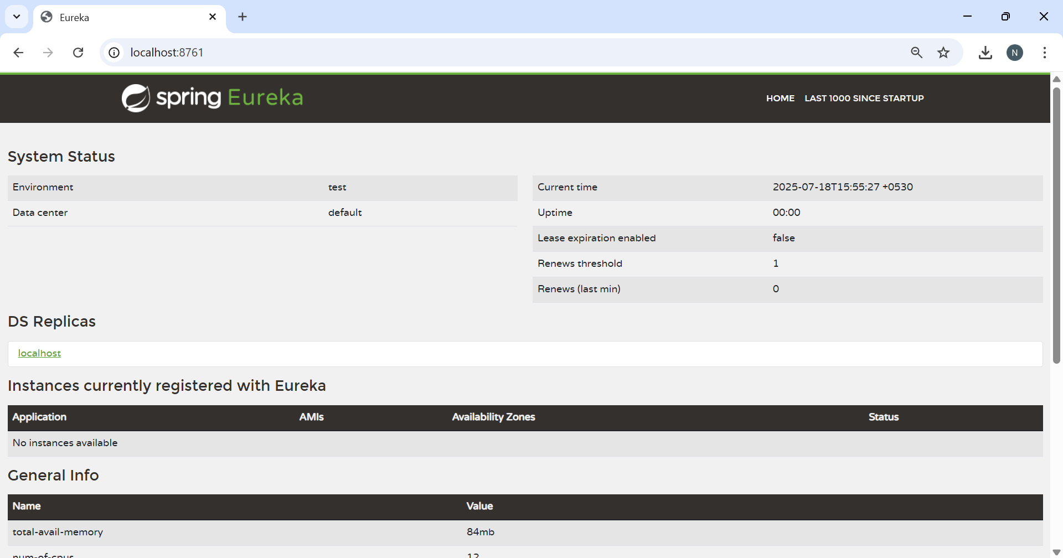

**Step-2:Register Account REST API to eureka discovery**

* Created a project with adding **Eureka-Discovery-Client** in springinitialzr along with same required dependencies and names of **account** and **loan microservices** done in previouses handsOns.
* Now updated this pom code with my existing pom files of accounts and loan projects.
* Added names as **account-service, loan-service** in **application.properties** in respective project files.
* Now first made eureka server to run and then opened the website localhost server.
* Then , opened account and loan one after another which are listed eureka server instances list.

**OUTPUT:**

**http://locahost:8761**

